**Grow Your Twitter**

**How to setup your profile:**

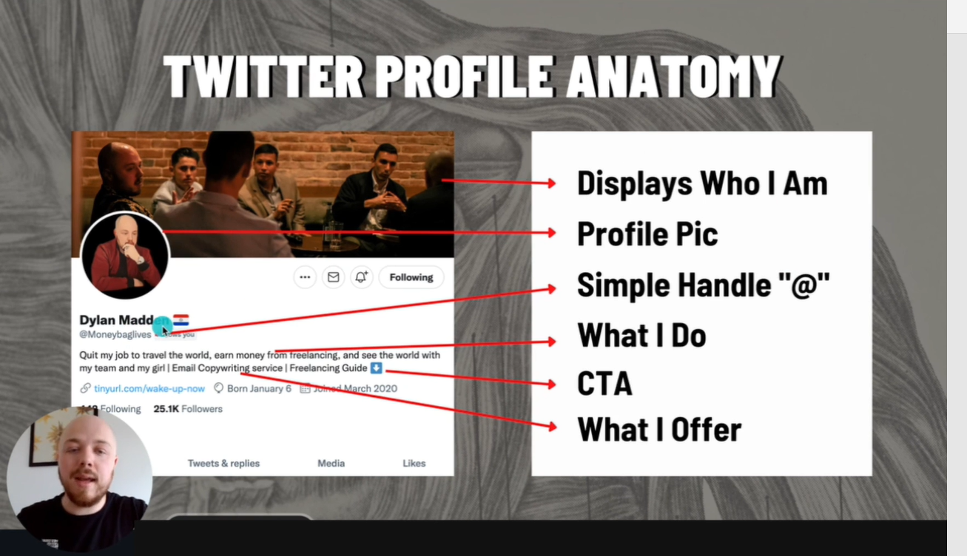

* Maximize all the above for best results
* **Header** illustrates what I do
* **Profile Pic** should be an original photo, not generic
* **Twitter bio** should be professional e.g.
  + Amateur bio: Hi, my name is John. I’m a photographer. Want to work together? Shoot me an email at [johnjones@gmail.com](mailto:johnjones@gmail.com) or DM me here
  + Professional Bio: I help influencers add 5 to 6 figures via email | Email Campaigns / Weekly Emails / Product Launches
* **Personal Brand** will possibly build your more power in the market. You can also upload both **personal** and **business** stuff
* Remember, your prospects want to know how you can help THEM, not what you do
* **CTA** stands for **C**all **t**o **A**ction
* Make your bio ABOUT the person that will be following you

**How to tweet:**

* Do not complicate this
* Share your own life experiences while implementing the following tweet styles

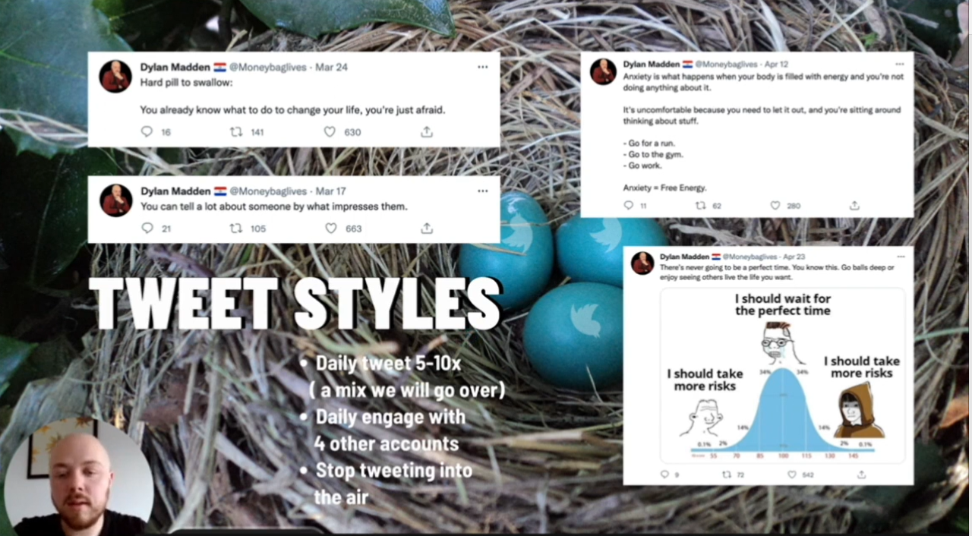

* Hook with a simple sentence as the next line.
* One sentence with value.
* List out your thoughts.
* Simple phrase with photos (i.e. memes)
* So, you’ll want to:
* Tweet daily 3-5x
* Daily engage with 4+ other accounts
* Stay consistent

**How to go viral:**

* Going vial requires: **intention, timing, and luck**
* Tips:
  + Use **attention-grabbing** words e.g.
    - Making ‘$’ in ‘x’ days
    - In your 20’s
    - $10/per month
    - Hard pill to swallow
    - Life hack
    - Passive income
  + Use proper spacing (Concise wordings)
  + Slightly controversial opinions to provoke commenting
  + Relatable
  + Short and punchy
  + Leveraging memes

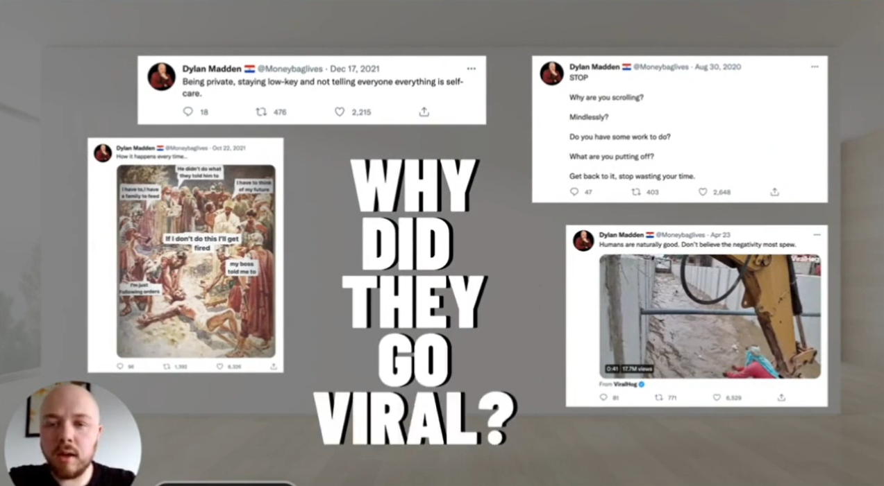

**How to comment like a pro:**

* Comment 5-10x per day on accounts with 2k+ followers
* Create lists to save time searching for accounts
* Amateur comment: True, be grateful!
* Professional Comment: You make a great point.  
    
  In today’s world most the ability to live in the moment.  
    
  Don’t forget to enjoy what you have now.

**How to write a thread:**

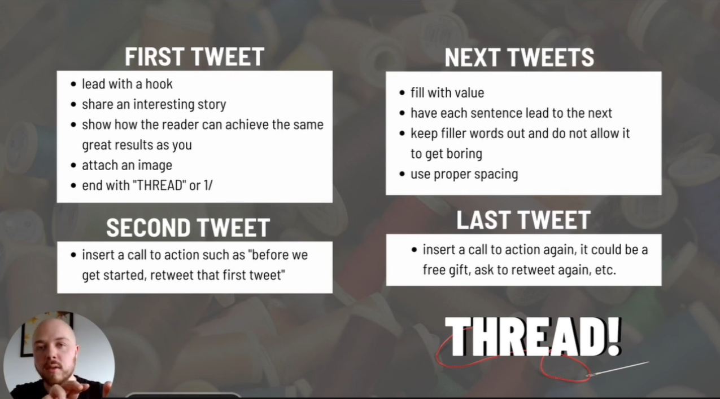

* **You’re using threads to:**
  + Provide value to your audience
  + Present your offer to new people
  + Break down a topic you're knowledgeable in to build your authority in your niche
  + Give lessons from your own life and how those lessons can help others You do NOT want to be boring
* You should write 1-2 threads a week

**How to build your email list:**

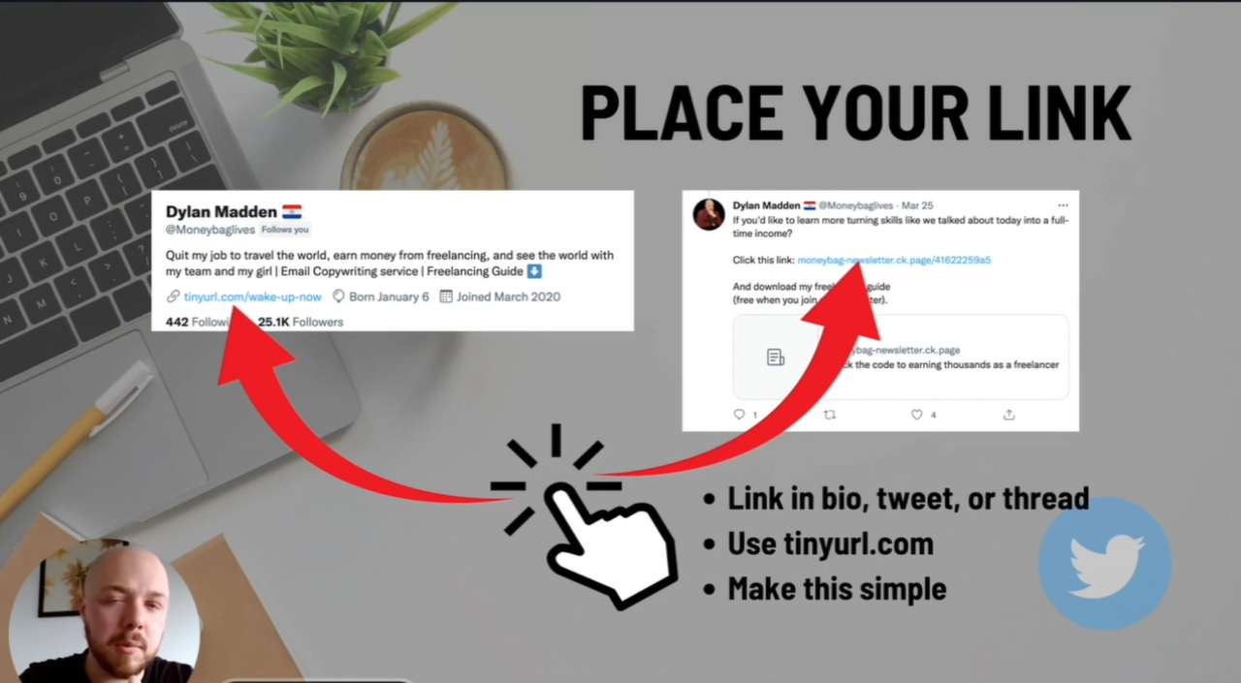

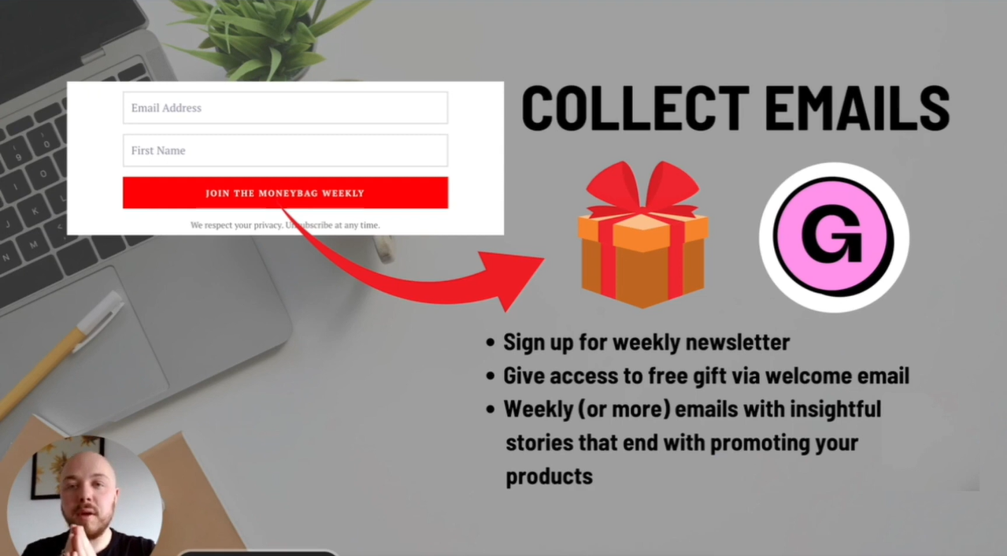

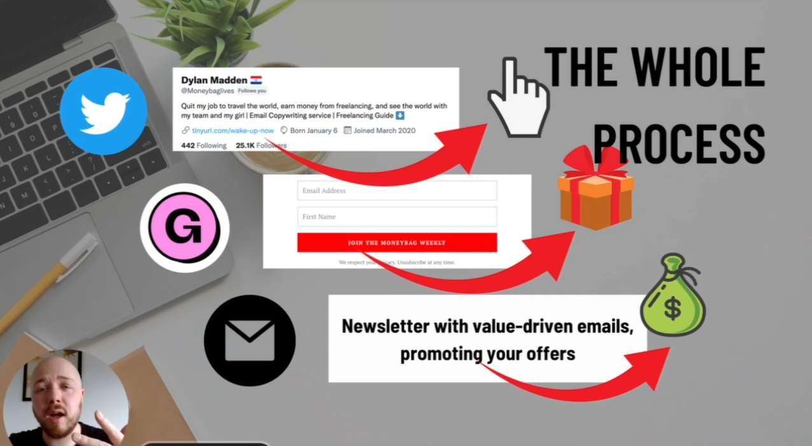

**How to earn money from your account:**

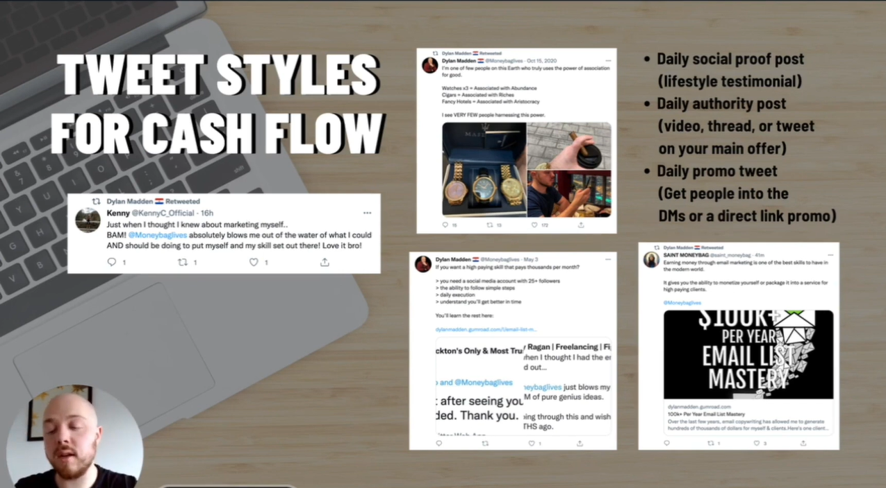

**How to approach your clients:**

* Build Rapport
* Follow their twitter account
* Engage with some of their tweets e.g., like them, reply to them etc
* Leave value when reaching them out in DMs
* **Do your own research**
* Don’t overextend the message (DM), get to the point
* Try different things
* **TEST TEST TEST**